Avadhut Vijay Talbar

Krishna Eknath Kabra

Kunal Gaurang Mehta

Mohit Shailesh Somaiya

Professor Koganti

CSE5301

12th December 2021

Lane Detection in Adverse Weather Conditions

Recently, an immense accentuation has been committed towards the implementation of Artificial Intelligence, Computer Vision, and Machine Learning in Vehicle-level Applications. Numerous models and studies have been conducted where vehicles have driven effectively over long separations for the clear climate condition. In any case, driving in unfavorable climate conditions isn’t well-considered and research is still going on. Unfavorable climate conditions can affect the various types of sensors and in-vehicle cameras and cause the models to decrease their accuracy accordingly, since the colors of the environment alter, as in rain or snow. We are going to present the descriptive analysis inclined within the course of impact on different in-vehicle utilities due to adverse weather causing poor predictions, and a brief comparison and examination of different strategies for road detection.

During normal weather conditions, the sensors such as LiDAR, Cameras work effectively. The car's sensors can be blocked by snow, ice, or rain droplets, and their ability to read road signs and markings can be affected up to a certain extent. Camera, LiDAR, and RADAR are the primary perceptual sensors that are usually adopted. However, because these are visible spectrum sensors, inclemency has a significant impact on the data. On a clear day, LiDAR can generate a high-resolution 3D image by bouncing laser beams off nearby objects, but it cannot see in fog, dust, rain, or snow.

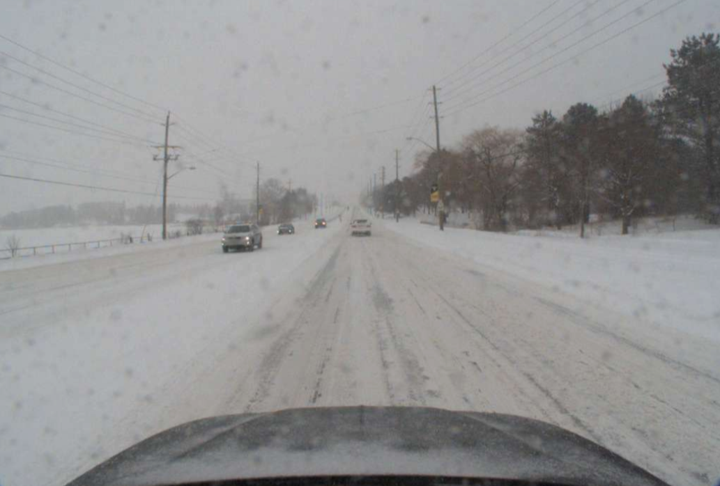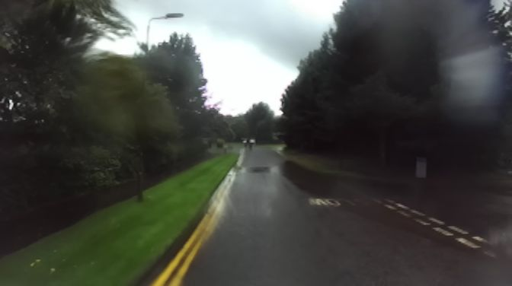

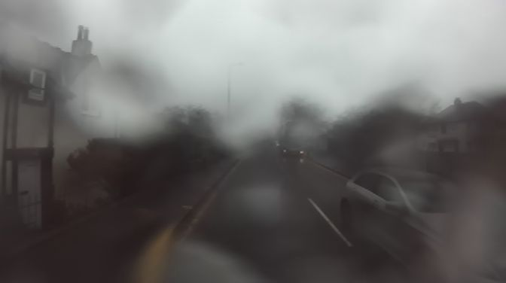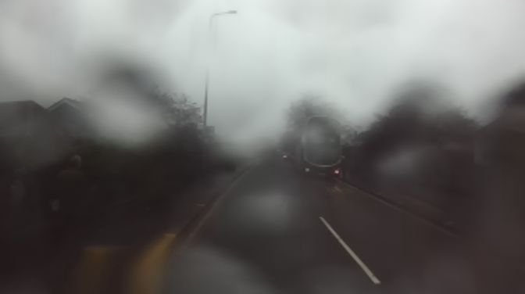

Fig. 1. Snow, Rain and Foggy Weather Images

Solutions for detecting lanes in adverse weather conditions are as below.

1. Train existing models on data collected in adverse weather using Deep Learning methods. Data can be collected using real/simulated adverse weather conditions. This will improve the performance of these models significantly.

2. Improve Light detection and ranging (LiDAR)

More than 95% of currently available LiDARs use 905 nm wavelengths. Changing to higher wavelengths (1550 nm) allows 20 times more power to be used than with the typical 905 nm wavelength.

3. Use of Multiple Radar   
 Radar based object detection is less affected by adverse weather, especially in foggy scenarios, where recognition from LiDAR data fails at a very short range depending on the fog density. We have a high likelihood of identifying the items that are present by having two radars at distinct vantage points with an overlapping field of view.  
The system consists of two radar sensors mounted on the bonnet, separated by about a car's width (1.5 meters).The device can observe more space and detail with two radars than with a single radar sensor.

For example, LiDAR-equipped cars traveling through dense fog will be unable to see anything through the fog.Simultaneously, this new multi-radar technology allows them to fly through all of these bad weather conditions, including fog and snow.

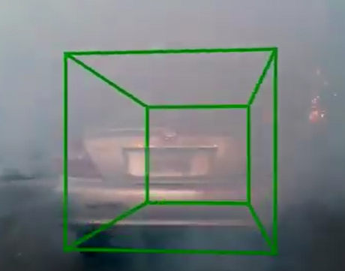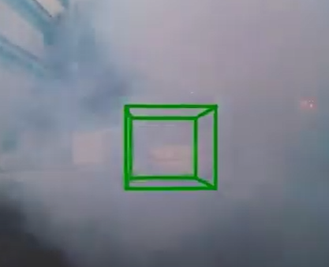

Fig. 2. Car detection on foggy condition

4. V2I communication

During worst weather conditions these onboard sensors such as cameras, LiDAR,

and radars are of very limited benefit. In the case when all of the above solutions fail one can

rely on Vehicle-to-Infrastructure(V2I) communication to retrieve images stored in the cloud,

which consist of the reference images captured at the same geographical location when

visibility was clear and weather conditions were good. These pictures are used to identify and

localize lane lines. Image registration techniques are used to align both the sensed images

during adverse weather and the reference image. Once both are aligned, the reference image's

lane line information is then placed on the local map created by the autonomous driving

system.

The sensed image in the snow day had no traces of the lane lines to be detected by a

lane line detection module. But, after applying the V2I framework it was possible to find lane

lines that can be used to assist the driver to navigate.

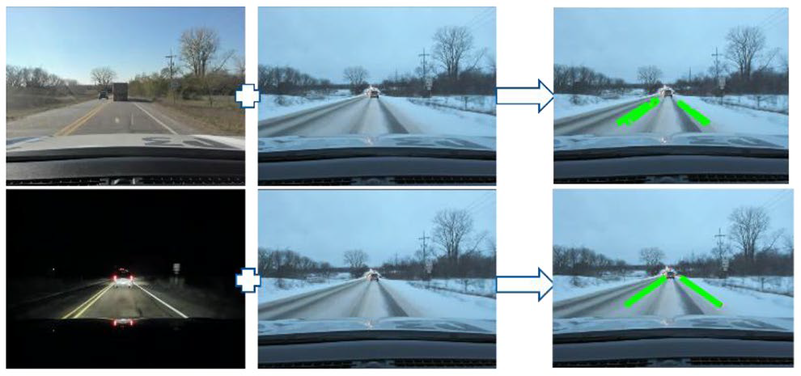

Fig. 3. The image shows the superimposed lines on image collected in adverse weather

5. De-weathering and Image Enhancement

The de-weathering / Image enhancement methods can be categorized into two types

first model-based methods and second non-model based methods.

For processing, non-model based approaches rely on the knowledge contained inside the

image.Histogram equalization is the best example of this method. One of the popular

non-model based algorithm used is Retinex Algorithm. The retinex is an image

enhancement algorithm that enhances an image's brightness, contrast, and sharpness.

The aim of the algorithm is to obtain a balance between the human vision and the machine

Vision. This algorithm suits a real-time vision based driver assistance system because of the

performance. This algorithm can produce a maximum performance of 34.1fps (frames per

second). This is greater than the real-time condition of 30fps.

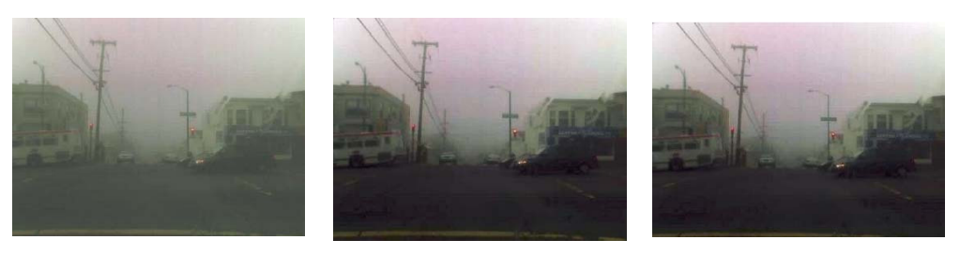

Fig. 4. Retinex algorithm results

Physical models are used in model-based approaches to anticipate the pattern of image

degradation.

Methods based on physics produce superior results.Researchers used many strategies to

address various bad weather situations like haze, fog, and rain. A few of the methods are

as below:

1. De-fog: It uses the moving mask technique to correct and enhance image quality. It is

presumed that the pixels in a mask have the same scene depth.

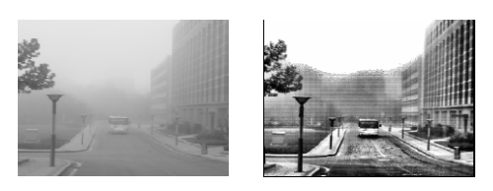

Fig. 5. Image enhancement based on moving mask-technique used under de-fog method

1. De-rain: The visual effects of rain are complex. E.g.: small size, high velocity, and

spatial distribution. The statistical characteristics of rain and snow are used in this

method in order to produce better results.

1. De-haze: Haze refers to the reduced contrast of an image. This method employs contrast correction techniques used in image analysis.

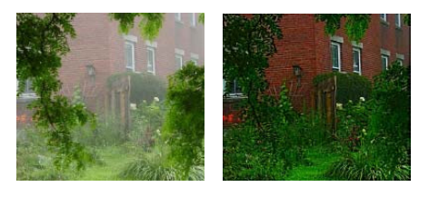

Fig. 6. Haze removal results

Conclusion

As per the analysis, it can be concluded that the following solutions can greatly

improvise lane detection in adverse weather conditions:

Training models using data that contains adverse weather data.

Using LiDAR of higher wavelength (1550nm) as compared to traditional LiDAR(905nm).

Using multiple Radars can enable the system to see more details in adverse weather

conditions.

Using reference images that were captured during clear weather conditions and

superimposing them on images captured in unclear weather can find candidate lane lines.

De-weathering the captured images can improve the visibility of road lanes.

Works Cited:

Heriot-Watt RADIATE Dataset. 2021. Welcome to Heriot-Watt RADIATE Dataset Website. [online] Available at: http://pro.hw.ac.uk/radiate/

Horani, M., & Rawashdeh, O. (2019, April 2). A framework for vision-based lane line

detection in adverse weather conditions using vehicle-to-infrastructure (V2I) communication. A Framework for Vision-Based Lane Line Detection in Adverse Weather Conditions Using Vehicle-to-Infrastructure (V2I) Communication. https://www.sae.org/publications/technical-papers/content/2019-01-0684/.

Kutila, M., Pyykonen, P., Holzhuter, H., Colomb, M., & Duthon, P. (1970, January 1). Automotive Lidar Performance Verification in fog and rain: Semantic scholar. Undefined. https://www.semanticscholar.org/paper/Automotive-LiDAR-performance-verification-in-fog-Kutila-Pyykonen/3ee48b297f3c590bf1523243df39c7d503982d73.

Review on state of art image enhancement and restoration methods for a vision based driver assistance system with de-weathering. IEEE Xplore. (n.d.). https://ieeexplore.ieee.org/document/6089128.

Robust multimodal vehicle detection in foggy weather using ... (n.d.). Retrieved from http://xyzhang.ucsd.edu/papers/Kun.Qian_CVPR21_MVDNet.pdf.

News release. Jacobs School News Item | Jacobs School of Engineering. (n.d.).

https://jacobsschool.ucsd.edu/news/release?id=3161

A. C. Aponso and N. Krishnarajah, "Review on state of art image enhancement and restoration methods for a vision based driver assistance system with De-weathering,"

2011 International Conference of Soft Computing and Pattern Recognition (SoCPaR), 2011, pp. 135-140, doi: 10.1109/SoCPaR.2011.6089128.

Nguyen, V. D., et al. “Robust Vehicle Detection Under Adverse Weather Conditions Using Auto-Encoder Feature.” International Journal of Machine Learning and Computing, vol. 10, no. 4, 2020, pp. 549–55. Crossref, doi:10.18178/ijmlc.2020.10.4.971.